OS PRATICAL
SIMPLE COMMANDS EXCUTIONS
COMMANDS
TOPIC 1
1.pwd
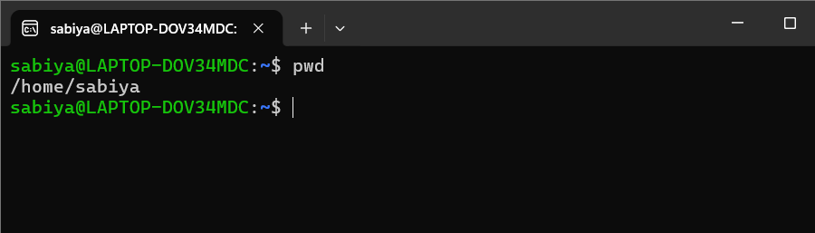
2.clear
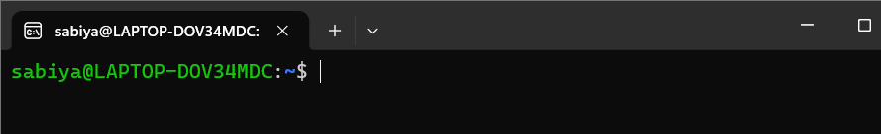
3.history
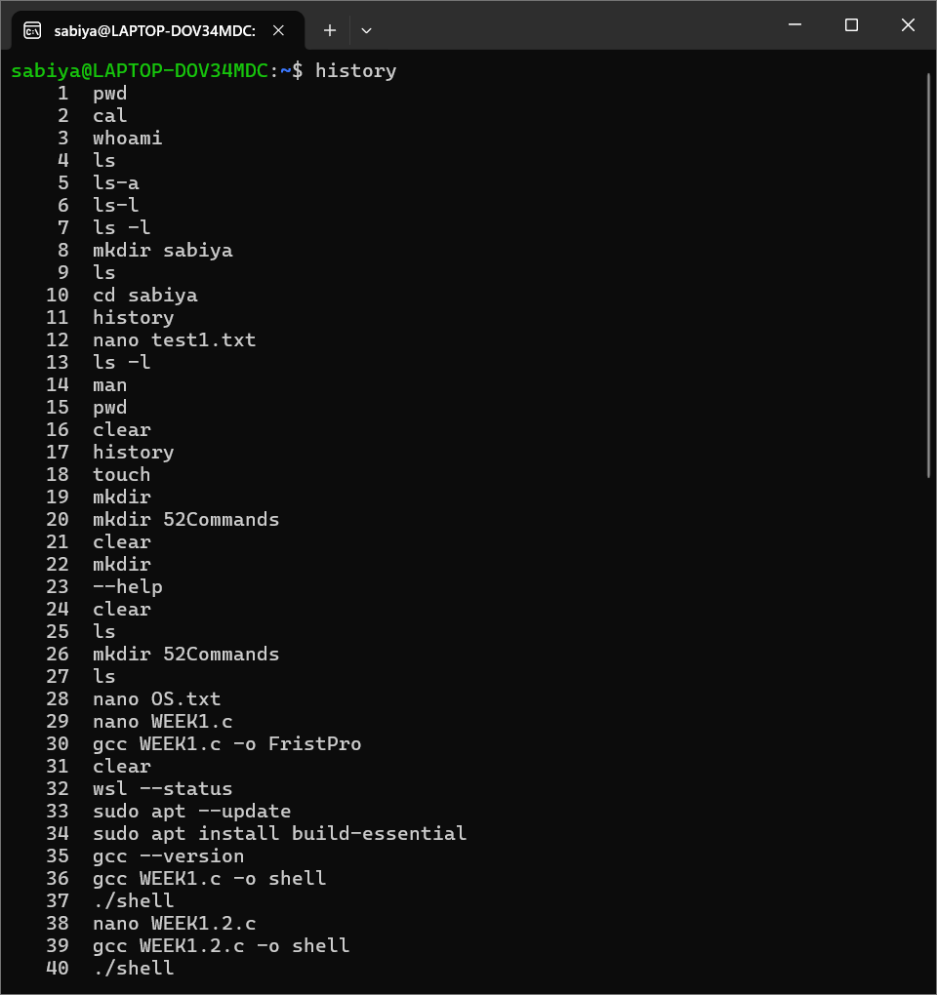
4.whoami
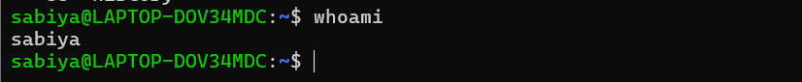
5. date
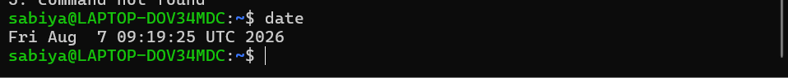
6.hostame
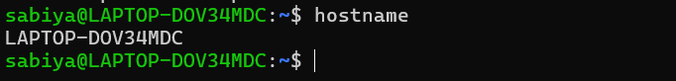
7.uname -a
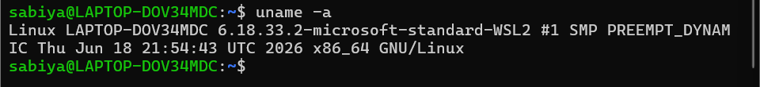
TOPIC 2
1.ls
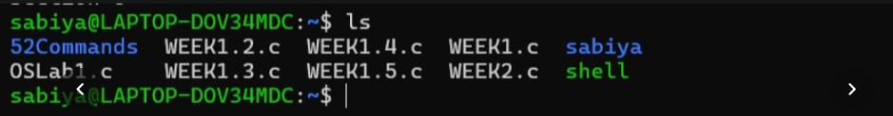
2.ls-l
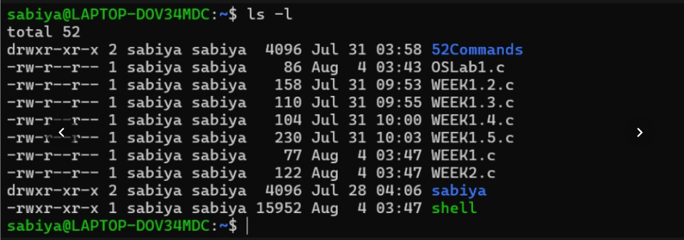
3.ls-a
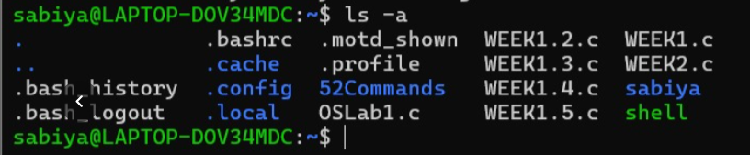
4.cd Documents
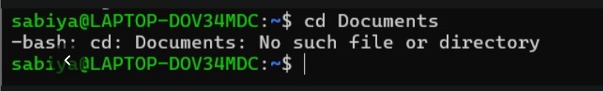
5.cd ..
6. mkdir OSLab
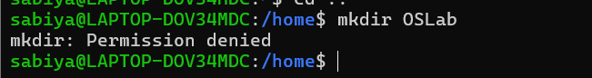
7. rmdir Test
8.find. -name “*.c”
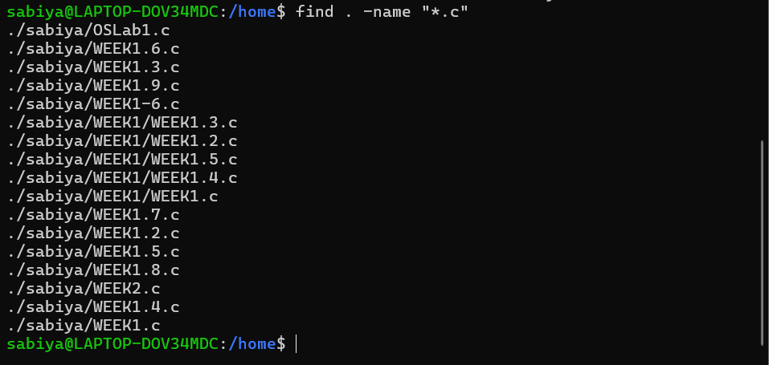
TOPIC 3
1.touch
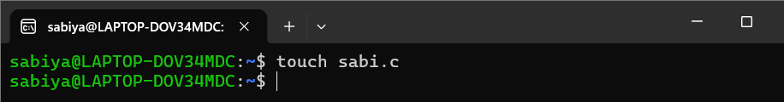
2.cat
